
Shustoke C.E. Primary School
Useful Websites for children starting school
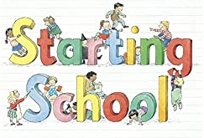
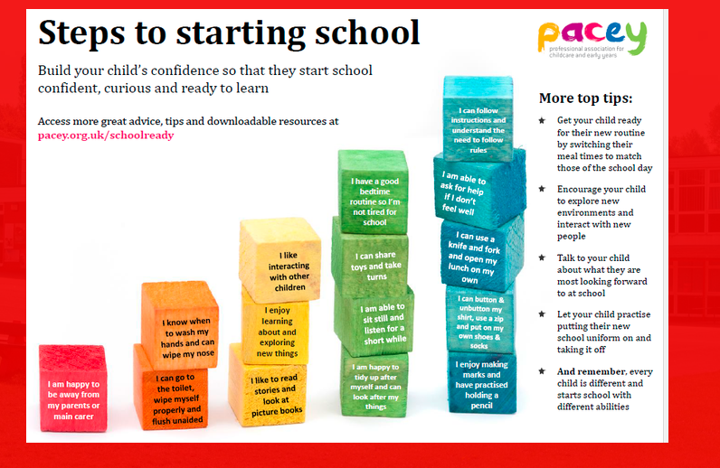
A guide to starting school
https://cdn.oxfordowl.co.uk/2018/06/27/15/30/15/280/Oxford_Owl_Starting_School_Guide_2018.pdf
Preparing your child for starting school useful tips for parents.
https://primarysite-prod-sorted.s3.amazonaws.com/springfield-primary/UploadedDocument/ffbfc3cc2b514a2791bffd458ffbb5d2/preparingforschool_guide.pdf
Oxford Owls provide top tips for children starting school
https://www.oxfordowl.co.uk/for-home/starting-school/getting-ready-for-primary-school/
Real-life experiences, memories and advice from teachers, parents and CBeebies presenters about starting school.
https://www.bbc.co.uk/cbeebies/grownups/starting-school-experiences

