Shustoke C of E
Primary School



RE Overview

 Understanding Christianity unit
 | Autumn 1 | Autumn 2 | Spring 1 | Spring 2 | Summer 1 | Summer 2
R | F1 How can people show they belong together? | F2 Why do Christians perform Nativity plays at Christmas?  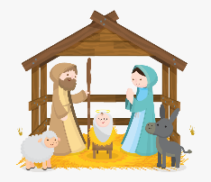  Incarnation | F2 Who are the people in sacred (special) stories and why might they still be important today? | F3 Why do Christians put a cross in an Easter garden?  Salvation |   F3 How do people know how to treat each other? | F1  Why is the World ‘God’ so important to Christians  God/Creation  
Y1  Worldviews content  Non-Religious  Humanist  Christian, Jewish, Muslim, Hindu and Buddhist teachings or the Golden Rule  Abrahamic  Sikh  Muslim  Catholic  Pegan | K1.1 How might your worldview be seen in the choices you make? | 1.3 Why does Christmas matter to Christians?  Incarnation  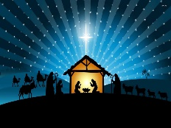 | K1.2 Where do people turn for guidance in life?  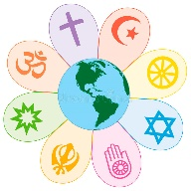 | 1.2 Who made the world?  Creation | Layover unit  (Jewish or Sikh) worldviews. | 1.3 How do people with similar worldviews share and celebrate their beliefs?
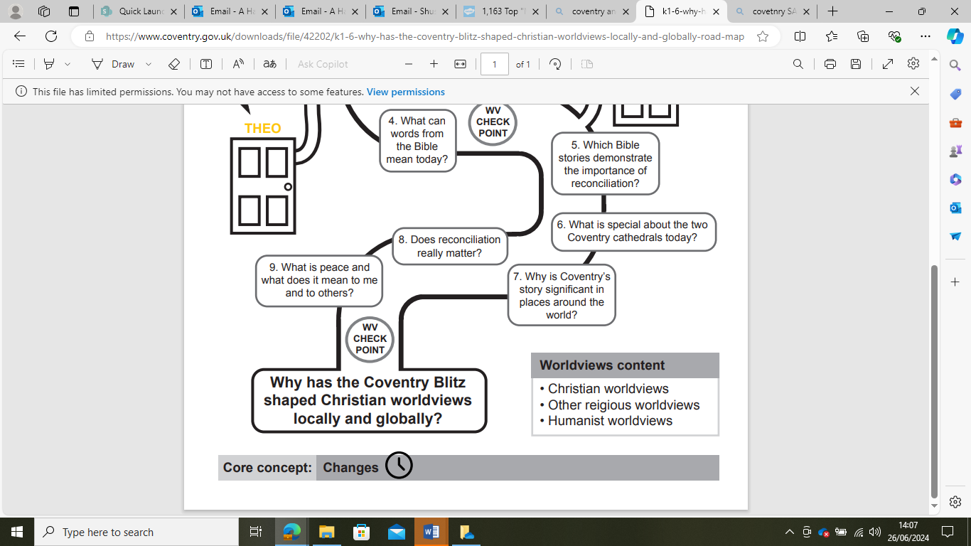  Y2  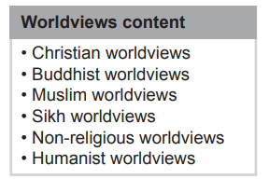 | Layover unit  Muslim worldviews | 1.3 Why does Christmas matter to Christians  Incarnation  (Blocked at Christmas) | K1.5 What is most important for different people   | 1.5 Why does Easter Matter to Christians?  Salvation | 1.4 What is the good news Jesus brings?  Gospel | K1.6 Why has the Coventry Blitz shaped Christian worldviews locally and globally?
 | Autumn 1 | Autumn 2 | Spring 1 | Spring 2 | Summer 1 | Summer 2
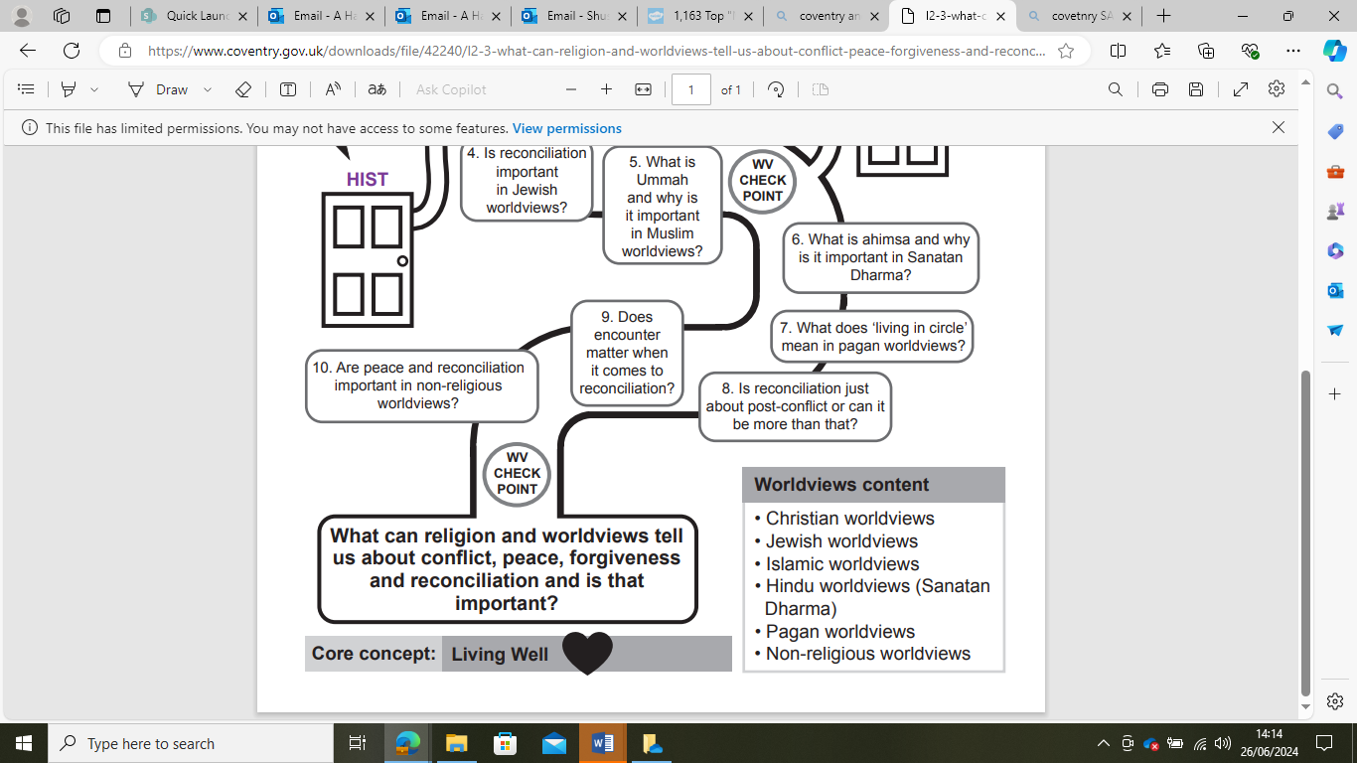  Y3  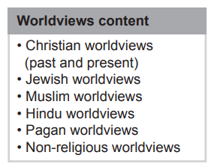 | L2.1 Why are nature and the seasons significant for religion and worldviews? | 2A.1 What do Christians learn from the creation story?  Creation | L2.2 How are worldviews shaped and expressed through art and architecture? | 2A.5 Why do Christians call the day Jesus died ‘Good Friday’  Salvation | 2A.6 When Jesus left, what was the impact of Pentecost?  Kingdom of God | L2.3 What can worldviews tell us about conflict, peace, forgiveness and reconciliation and is that important.  and  2A.4 What kind of world did Jesus want?  Gospel
Y4  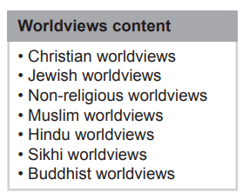  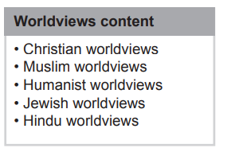  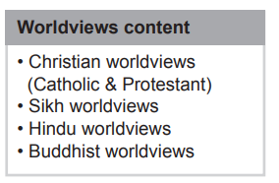 | L2.4 How might your worldview lead you to do hard things for good reasons? | Layover unit  Theistic worldview | 2A.3 What is the Trinity?  Incarnation/God | L2.5 What or who is ‘God’ and how is the divine understood theistic worldviews? (Omit Trinity) | L2.6 Do you have to be part of a faith community to hold an organised worldview?  including elements of 2.A4 What kind of a world did Jesus want?  Gospel | L2.7 How have religion and history entwined in this area?
Y5  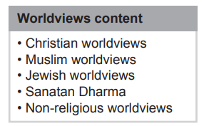  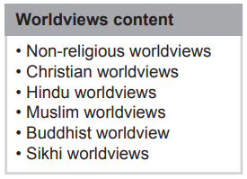  Humanist | Why might ancient stories still be so important for some worldviews today? | 2.B4 Was Jesus the Messiah?  Incarnation  (blocked at Christmas) | U2.3 Do religion change or do they stay the same? | 2B.6 What did Jesus do to save human beings?  Salvation | U2.4 What might it mean to ‘live well’? | 2B.5  What would Jesus do?  Gospel
Y6  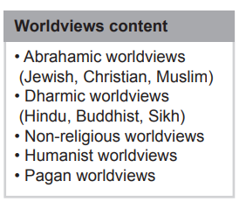  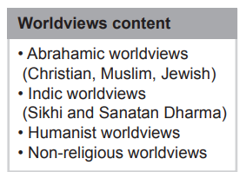  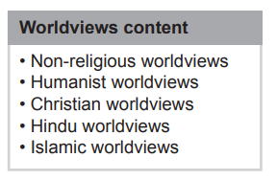 | U2.5 How do beliefs and ideas about land shape the way human beings live?  (Omit environmental aspect) | 2B.2 Creation and Science: conflicting or complementary?  Creation/Fall  and  2B.8 What kind of kings is Jesus?  Kingdom of God  (blocked at Christmas) | Layover Unit  Hindu Worldviews  And  U2.6 How might your worldview impact on the way you understand death and beyond? | 2B.7 What difference does the resurrection make to Christians?  Salvation | U2.7 What is truth and where might it be found? | 2B.3 How can following God bring freedom and justice?  People of God

