Harvest Festival

The children performed songs and poems to their parents and the wider community to celebrate Harvest. The children also bought in food donations which were distributed to the older population within the community.

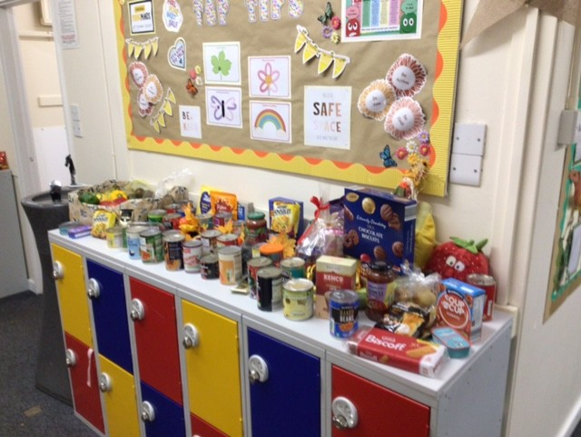
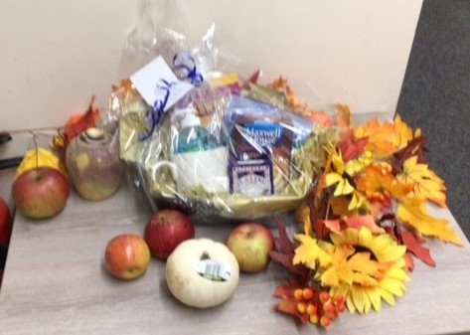

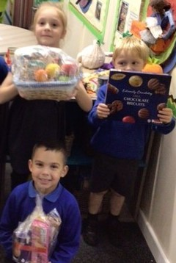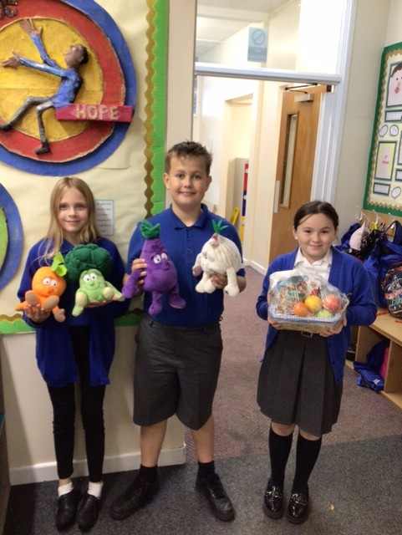
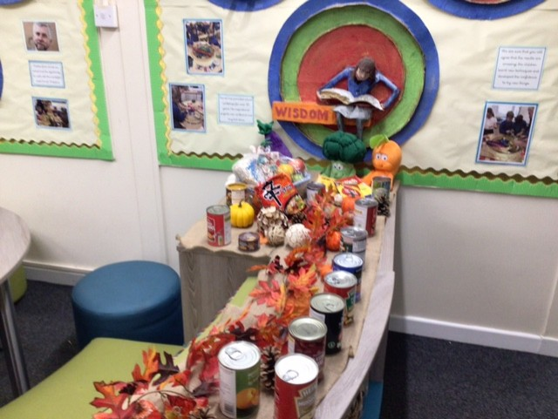

Dear God,
Thank you for the food that grows from all around the world which we eat from the tables at school and home.
Help us to be thankful for those who produce, harvest and transport our food.
May we never forget to use the world’s resources wisely and for the good of everyone.
Amen

