October 2022 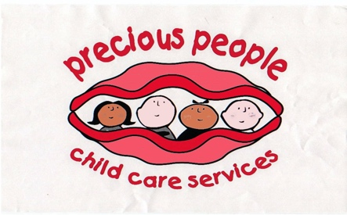 

Safeguarding Children Policy

Mobile Phones

Precious People will endeavour to provide a safe setting for all children in our care and inorder to make sure that we do this we are asking that any persons coming into our clubs do not use their mobile phones for calls or for taking photographs/videos.

All staff must surrender their mobile phones to the manager before the children arrive in the setting and all phones will be locked away safely until the end of the session.
We ask that all parents/guardians do not make or receive phone calls during their visit to our setting, we ask that all calls if any are taken outside of the setting and that all cameras or video settings are turned off before entering our club

We thank you for all your help and support in ensuring that we provide a safe aswell as stimulating environment for your child whilst in our care.

Thank you
Fiona and staff To be revised October 2023
07977074726
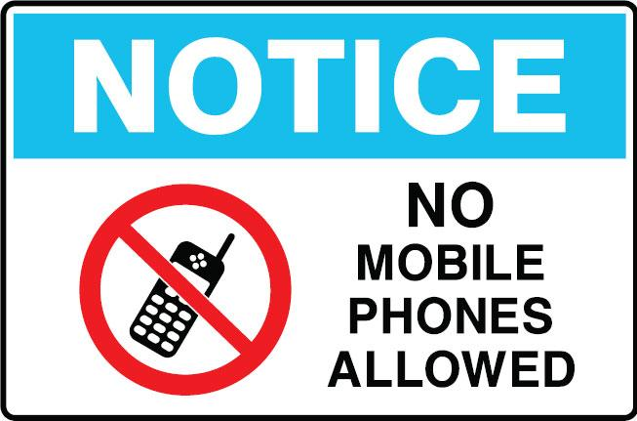
This Photo by Unknown Author is licensed under CC BY-SA

