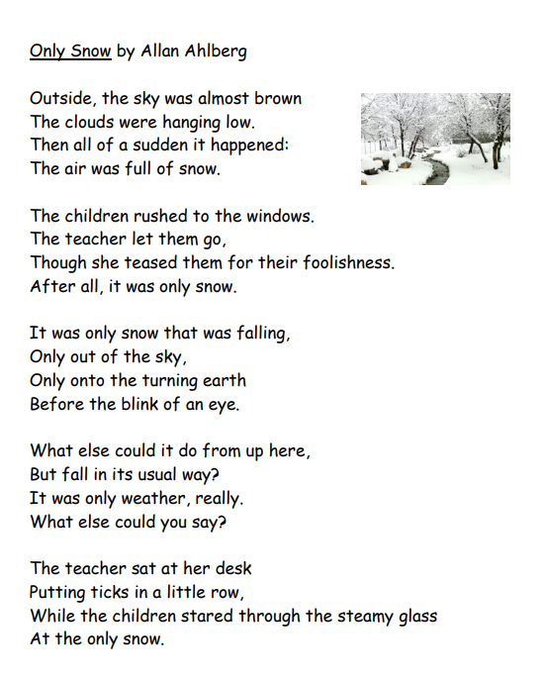

If there are any words you would like to clarify, use the link below to look them up in an online dictionary. https://kids.wordsmyth.net/we/

Answer the questions about the poem, in full sentences.

- What colour was the sky?

- Why did the children “rush” to the windows and “stare” at the snow? How were they feeling?

- What are the children thinking as they look at the snow? Write 3 ideas.

- What did the teacher think of the snow?

- Why do you think the poet repeats the word “only”?

- How do you feel when you see snow falling?

- What do you like to do in the snow?

